The Critical Role of Jobsite Cleanliness and Safety in Modern Construction

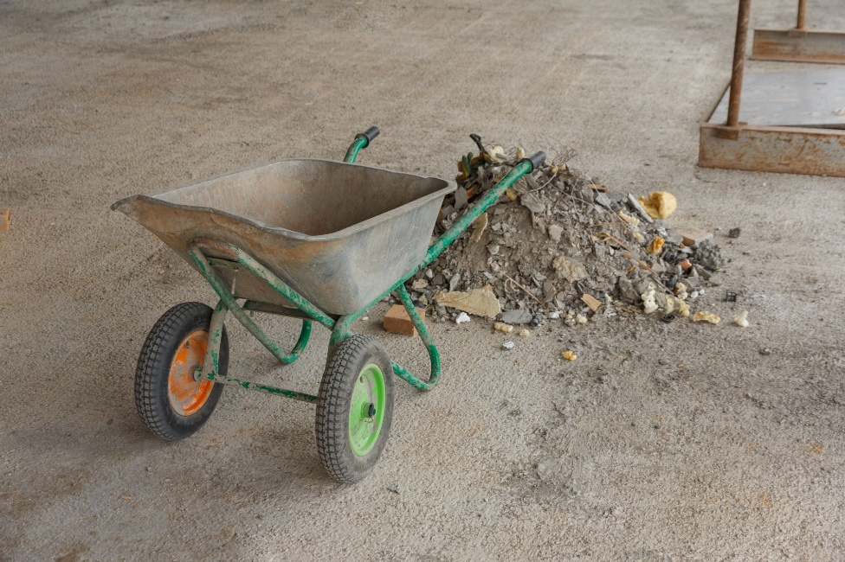

In today’s construction environment, expectations around safety, quality, and professionalism are higher than ever. Owners demand predictable outcomes; agencies enforce strict compliance, and contractors must demonstrate disciplined execution from the first day on site. Across every sector, healthcare, education, government, and commercial facilities, one factor remains constant: a clean, organized, and safety-driven jobsite is essential for successful project delivery.

Cleanliness and safety are inseparable. Sites that maintain strong housekeeping practices experience fewer incidents, reduce schedule delays, protect material quality, and promote more efficient workflows. At KR Wolfe, these principles are not optional; they are embedded in our culture, our training, and our daily operations.

Clean Jobsites Drive Productivity and Quality

A clean job site establishes the tone for the entire project. When debris is cleared promptly, pathways are unobstructed, and materials are properly staged, every trade on site benefits. Productivity increases because teams can work without navigating clutter or inefficiencies. Quality improves because materials and tools remain protected from damage.

Cleanliness also protects the project’s long-term integrity by reducing dust, moisture exposure, and environmental damage, issues that can compromise finishes, MEP systems, and structural components.

Safety Starts with Housekeeping
Most jobsite injuries are preventable, and poor housekeeping is one of the leading causes of accidents. Trip hazards, scattered tools, unorganized materials, and obstructed pathways all elevate the risk of injury. A well-maintained job site eliminates these hazards and reinforces safe behavior.

Key safety advantages of a clean site include:
- Fewer slip-and-trip risks
- Clear access to ladders, exits, and active work areas
- Proper storage of hazardous materials and power tools
- Better visibility for equipment operators and labor crews
- Reduced fire hazards from debris and discarded materials

When workers step onto a controlled, orderly site, it signals that safety is a core priority, not a checkbox.

Cleanliness Strengthens a Contractor’s Reputation

Owners, inspectors, and stakeholders form opinions long before the project reaches completion. A clean job site communicates professionalism and organization. It shows that the contractor respects the property, manages crews effectively, and takes pride in the work.

Inspections Rely on a Clean and Safe Jobsite

A disorganized or unsafe job site creates obstacles during inspections. Inspectors need clear visibility of the work performed and safe access to every required area. Clutter or hazards can delay approvals, trigger re-inspections, or even prompt corrective action.

A clean job site signals readiness. It suggests that craftsmanship is complete, documentation is in order, and the contractor is prepared for the next phase. This directly improves inspection success rates and keeps projects on schedule.

How KR Wolfe Maintains Clean, Safe, and Inspection-Ready Jobsites

KR Wolfe operates under a disciplined job site management philosophy that prioritizes cleanliness and safety as daily, non-negotiable practices. Our approach combines structure, accountability, and proactive communication.

Daily Housekeeping Protocols

KR Wolfe teams conduct cleanup and organization throughout the day, not just at the end of a shift. Technicians return tools to the designated storage, remove debris immediately, and maintain orderly materials. This continuous approach ensures the site always remains safe and efficient.

Defined Staging and Storage Zones

We establish material laydown areas, waste collection points, and operational pathways from day one. This prevents clutter, maintains clear traffic flow, and allows all trades to work without obstruction.

Safety Walks and Routine Audits

Site supervisors perform routine safety walks to identify hazards, enforce housekeeping standards, and correct issues before they escalate. In addition, our site supervisors document these inspections to drive ongoing improvements.

Training and Culture

Every KR Wolfe employee receives safety and housekeeping training tailored to active facility environments, hospitals, federal labs, behavioral health spaces, hotels, and veterinary hospitals, where our clients require cleanliness. Clean sites are a point of pride, and leadership reinforces these expectations daily.

Respect for Active Environments

We frequently work in occupied and operational facilities. Our teams are trained to work quietly, cleanly, and with minimal disruption, protecting patients, staff, animals, clients, and sensitive equipment. This experience has shaped our approach to cleanliness as an operational standard, not a project phase.

Inspection-Ready Standards

We manage our jobsites as if an inspector could arrive at any moment. This ensures:

- Clear access
- Safe working conditions
- Proper labeling and temporary protections
- Fully compliant installation staging
- Immediate readiness for review

Because of this philosophy, KR Wolfe’s projects consistently achieve smooth inspections and reduce costly re-inspections or delays.

Final Perspective

Jobsite cleanliness and safety are foundational to delivering successful construction projects. At KR Wolfe, we embedded these principles in the way we build. Through disciplined housekeeping, structured safety processes, and a culture that demands excellence, we maintain jobsite conditions that meet the highest standards of professionalism and compliance.

